APPENDIX 3 – SAFEGUARDING INCIDENT FORM
This form should be filled as fully as possible by the concerned person who then passes it on to the DPS.
The DPS will complete their own copy of this form, both copies to be kept together.
The concerned person only needs to fill this page and the body map (if appropriate)

Name of church / organisation | Cairns Road Baptist Church
Contact details of church / organisation | Westbury Park, Bristol, BS6 7TH
Name of Designated Person for Safeguarding (DPS)*
Contact details of Designated Person for Safeguarding*
Name of concerned person or to whom disclosure was given
Contact details of concerned person or whom disclosure was given

INDIVIDUAL OF CONCERN (the child or vulnerable adult) CONTACT DETAILS

Name
Date of birth
Address
Phone number / Email address

THE INCIDENT

What happened? (Nature of concern / disclosure made - use the person’s own words if known

When did it happen? (date, time)

Where did it happen? (specific location)

Who was allegedly involved and in what way? (includes witnesses)

When was it reported to the concerned person

Have the carers or parents / guardians been informed? If so, when and by whom?

Signature of concerned person Date / Time

ANY ACTION THAT HAS BEEN TAKEN

Yes |  | No
Have the carers or parents / guardians been informed? (Please tick)
If so, when and by whom?
Yes |  | No
Have the statutory authorities been informed?
If so, please complete the table:

Authority (eg Police, Soc Services)
Name
Position
Email contact
Phone contact
Contacted by
Date & time of contact

Yes |  | No
Has the Local Association been informed?
(Please do so if the statutory authorities are involved)
If so, when and by whom?
Any other action taken:

FUTURE ACTION TO BE TAKEN

What action needs to be taken?

Who is responsible for this?

SIGNATURES

Signature of Designated Safeguarding Person |  | Signature of Trustee or other Church Safeguarding Team member
Date & time |  | Date & time

BODY MAP

Name of Individual of Concern_______________________________________________________

Name of person completing this form_______________________________________________

These diagrams are designed for the recording of any observable bodily injuries that may appear on the person. Where bruises, burns, cuts, or other injuries occur, shade and label them clearly on the diagram. Remember it’s not your job to investigate or to decide if an injury or mark is non-accidental. Listen, observe and pass it on.
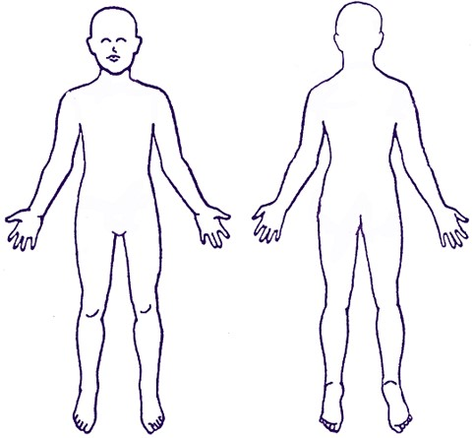
Front Back

Signature _________________________________________________

Date and time ____________________________________________

