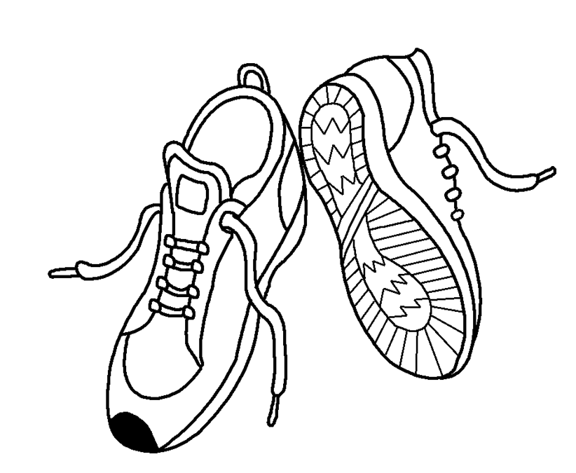

What colour are your trainers?

Where can you run this week?

In the space below, can you draw a story from the Bible that you have heard this week?

‘And we must be determined to run the race that is ahead of us. **2**We must keep our eyes on Jesus, who leads us and makes our faith complete.’ Hebrews 12:1-2



