Cairns Road Baptist Church
Children’s Safeguarding Policy and Procedures 2016 update

This document is written under the guidance of the Baptist Union’s publication ‘Safe to Grow’ Sixth edition 2011.

This document is for all children and youth work held or run from Cairn’s Road Baptist Church and is available for all paid workers and volunteers.

Group leaders have a responsibility to have read this document to ensure their group is run in accordance to the policy and procedures put in place to safeguard the children and young people in our care.

Volunteers are required to have at least read their own group booklet highlighting the policies and good practice procedures relevant to their role taken from this document (under the direction of their group leader).

Content:

Page | Item
2 | Policy statement- displayed within the building
3 | Information poster for responsible persons- displayed within the building
4 | Definitions of Abuse
4 | What might lead us to think that a child is being harmed?
5 | Who causes harm to children?
6 | How can children express their concerns?
7-10 | Procedure for responding to concerns
10 | When the concern involved the Responsible Person
10 | When concerns are expressed about the Minister
11 | What do we do if we have a know offender in the church?
11 | How should volunteer workers be appointed?
13 | What do we do about renewing checks for our workers?
13 | Young leaders under 18 years of age
13 | Practical pointers for working with young leaders
14 | Use of photography
15 | Good practice guidelines content list

Policy statement
Cairns Road Baptist Church
Child protection Policy Statement

Church: Cairns Road Baptist Church (CRBC)
Meets: Cairns Road, Cairns Road, Westbury Park, Bristol, BS6 7TH
Office: Cairns Road, Westbury Park, Bristol, BS6 7TH
Cairns Road Baptist Church is affiliated to the Baptist Union of Great Britain, the West of England Baptist Association

The church recognises its responsibilities for the safeguarding of all children and young people under the age of 18 (regardless of gender, ethnicity or ability) as set out in The Children Act 1989 and 2004, Safe from harm (HM government 1994) and Working together to Safeguard Children (HM Government 2010)

As members of this church we commit ourselves to the following policies and to the development of procedures to ensure their implementation.
Presentation and reporting of abuse
It is the duty of each church member and each member of the wider church family to prevent the physical, sexual and emotional abuse of children and young people and the duty of all respond to concerns about the well-being of children and young people and to report any child abuse disclosed, discovered or suspected. The church will fully co-operate with any statutory investigation into any suspected abuse linked with the church.

Safe recruitment, support and supervision of workers
The church will exercise proper care in the selection and appointment of those working with children and young people, whether paid or voluntary. All workers will be provided with appropriate training, support and supervision to promote the safeguarding of children.

Respecting children and young people
The church will adopt a code of behaviour for all who are appointed to work with children and young people so that all children and young people are shown the respect that is due to them.

Safe working practices
The church is committed to providing a safe environment for activities with children and young people and will adopt ways of working with children and young people that promote their safety.

A safe community
The church is committed to the prevention of bullying of children and young people. The church will seek to ensure that the behaviour of any who may pose a risk to children and young people in the community of the church is managed appropriately.

Responsible people
The church has appointed the following persons:
Mark Corcoran (contact person)
Jenny Bush (contact person, policy and procedure monitor)
Their role is as follows:
- Oversee and monitor implementation of the policy and procedures on behalf of the church’s charity elderships.
- Advise the church on any matters related to the safeguarding of children and young people
- Take the appropriate action when abuse is disclosed, discovered or suspected.
- One member of the Responsible Persons team must be part of the eldership team

Policy and procedures
A copy of the policy statement will be displayed permanently on the notice boards within the church and Noah’s Ark.
Each worker with children and young people whether paid or voluntary will be given a full copy of the policy and procedures and will be required to follow them.
A full copy of the policy and procedures will be made available on request to any member of the church, the parents or carers of any child or young person from the church and any other persons associated with the church.
The policy and procedures will be monitored and reviews at least annually.
The policy statement will be read annually at the AGM together with the report on the outcome of the annual review.

To be displayed on Cairns Road Baptist Church’s notice boards. This was updated and agreed in Cairns Road Baptist Church’s members meeting October 2013
Annual renewal due Autumn 2013. For more information please contact the Church office Email: office@cairnsroad.org Phone: 0117 942 5669

Cairns Road Baptist Church

In accordance with its Child Protection Policy and Procedures has appointed the following people as ‘Responsible Persons’

Mark Corcoran (contact person)
0117 924 8594
Jenny Bush (contact person and policy & procedures monitor)
07812 705 907

A Responsible Person is the contact point for concern over the safety of any child or young person the church has contact with.
Any adult, parent or child is free to contact them for any of the following reasons:

Any matters arising from the Child Protection Policy

Concern for a child or young person’s well being either from observation or what the child or young person has told you

If you need advice with dealing with a child or young person’s safety

If you need advice over a concern of another adult’s actions or an observation you have made of their behaviour.

If you are unable to reach any of the Responsible Persons and you need to act quickly please seek advice either from North Bristol, Social Work Assessment team: 0117 903 8700 and ask for FIRST RESPONSE or Churches’ Child Protection Advisory Service (CCPAS) 01322 667207
More advise can be found from Southwest child protection procedures www.swcpp.org.uk
Alternatively, contact your local police station on 101 or if a child is in immediate danger dial 999.

Definitions of Abuse
The definitions of child abuse recommended as criteria for registration throughout England and Wales by the Department of Health, Department of Education and Employment and the Home Office in their joint document, Working Together To Safeguard Children (1999) are as follows:

Abuse and neglect
Somebody may abuse or neglect children by inflicting harm or by failing to act to prevent harm. Children may be abused in a family or in an institution or community setting; by those known to them or more rarely, by a stranger.

Physical abuse
Physical abuse may involve hitting, shaking, throwing, poisoning, burning or scalding, drowning, suffocating, or otherwise causing physical harm to a child. Physical harm may also be caused when a parent or carer feigns the symptoms of, or deliberately causes ill health to a child whom they are looking after. This situation is commonly described using terms such as factitious illness by proxy or Munchausen syndrome by proxy.

Emotional abuse
Emotional abuse is the persistent emotional ill-treatment of a child such as to cause severe and persistent adverse affects on the child’s emotional development. It may involve conveying to children that they are worthless or unloved, inadequate, or valued insofar as they meet the needs of another person. It may feature age or developmentally inappropriate expectations being imposed on children. It may involve causing children to frequently feel frightened or in danger, or the exploitation or corruption of children. Some level of emotional abuse is involved in all types of ill-treatment of a child, though it may occur alone.

Sexual abuse
Sexual abuse involves forcing or enticing a child or young person to take part in sexual activities, whether or not the child is aware of what is happening. The activities may involve physical contact including penetrative or non-penetrative acts. They may include non-contact activities, such as involving children in looking at, or the production of, pornographic material or watching sexual activities, or encouraging them to behave in sexually inappropriate ways.

Neglect
Neglect is the persistent failure to meet a child’s basic physical and/or psychological needs, likely to result in the serious impairment of the child’s health or development. It may involve a parent or carer failing to provide adequate food, shelter or clothing, failing to protect a child from physical harm or danger, or the failure to ensure access to appropriate medical care of treatment. It may also include neglect of, or unresponsiveness to, a child’s basic emotional needs.

Organised abuse
Organised or multiple abuse may be defined as abuse involving one or more abuser and a number of related or non-related abused children and young people. The abusers concerned may be acting in concert to abuse children, sometimes acting in isolation, or may be using an institutional framework or position of authority to recruit children for abuse. Organised and multiple abuse occur both as part of a network of abuse across a family or community and within institutions such as residential homes or schools.

Spiritual Abuse
Linked with emotional abuse, spiritual abuse could be defined as an abuse of power, often done in the name of God or religion, which involves manipulating or coercing someone into thinking, saying or doing things without respecting their right to choose for themselves. Some indicators of spiritual abuse might be a leader who is intimidating and imposes his/her will on other people, perhaps threatening dire consequences or the wrath of God if disobeyed. He or she may say that God has revealed certain things to them and so they know what is right. Those under their eldership are fearful to challenge or disagree, believing they will lose the leader's (or more seriously God's) acceptance and approval.

What might lead us to think that a child is being harmed?
Knowing whether a child is being abused or neglected may be difficult to judge. However, all those who have contact with children and young people should be alert to the potential indicators of abuse and neglect and know how to respond to any concerns they may have.
On occasions an incident or an injury will give cause for concern but often it is a series of incidents or an accumulation of concerns which indicate that a child may be suffering or at risk of suffering harm.
- Children and young people might share with a trusted adult a concern they have about their safety or disclose that they are being abused.
- A child’s observed behaviour, their physical appearance, developmental progress and emotional demeanour might indicate that they are being abused or neglected. When sudden changes in the child’s behaviour occur, abuse might be a possible reason for this.
- How adults behave might also give rise to concern. Parents and carers might indicate that they are experiencing difficulties which are having adverse and potentially damaging effects on their child(ren) or observations of an adult’s interaction with a child or young people might give cause for concern.
Whilst it is not possible to be prescriptive about the signs and symptoms of abuse and neglect, the following lists set out some of the indicators which might be suggestive of abuse:
- Unexplained or suspicious injuries such as bruising, cuts or burns, particularly if situated on a part of the body not normally prone to such injuries;
- An injury for which the explanation seems inconsistent;
- Injuries which have not received appropriate medical attention;
- A child or young person describes what appears to be an abusive act involving him/herself;
- A disclosure or allegation made by a child or young person;
- Someone else (a child or adult) expresses concern about the welfare of another child or young person;
- Unexplained changes in behaviour or mood (e.g. becoming very quiet, withdrawn or displaying sudden outbursts of temper);
- Inappropriate sexual awareness;
- Engaging in sexually explicit behaviour or play;
- Nervousness/watchfulness;
- Inappropriate relationships with other children and/or adults;
- Signs of neglect, such as under-nourishment, untreated illnesses, inadequate care.
IT SHOULD BE RECOGNISED THAT THIS LIST IS NOT EXHAUSTIVE AND THE PRESENCE OF ONE OR MORE INDICATORS IS NOT IN ITSELF PROOF THAT ABUSE IS ACTUALLY TAKING PLACE. IT IS ALSO IMPORTANT TO REMEMBER THAT THERE MIGHT BE OTHER REASONS WHY MOST OF THE ABOVE ARE OCCURRING.
Who causes harm to children?
‘Children may be abused in a family or in an institutional or community setting; by those known to them or more rarely by a stranger’ from Working Together to Safeguard Children- Department of Health 1999
It is important to recognise that children and young people can be subject to abuse in any and every setting where they have contact with adults. The abuse may be of a physical, sexual or emotional nature and it is important for those working with children and young people to be aware that abuse may be perpetrated by both males and females and by other children and young people.
The person who brings harm to children and young people:
- Is most often someone known to the child (they may be a parent, sibling, other relation, family friend or neighbour)
- Is often an adult with whom the child or young person has a valued relationship and may be in a position of trust and responsibility within an organisation to which a child belongs or has contact
- Can be of any background (social, economic, cultural, ethic etc)
- May act in isolation or together with other adults.
In situations where children and young people abuse other children, they are likely to be children who have considerable needs of their own, sometimes as a result of abuse, neglect, disruption and instability they have experienced. The risk they pose to other children should not be overlooked.
How can children express their concerns?
All children and young people should be valued and listened to, and their views and wishes taken into account.
Children and young people sometimes share views, worries, anxieties and concerns with adults with whom they have contact. Whenever they express concerns about their safety and protection in relationship to physical, sexual and emotional harm, we help to protect them by listening to them and taking seriously what they say. Their views and wishes should be respected and taken into account, in so as far as this is consistent with their safety and protection.
Children who are being abused will often only talk about what has happened to them to people they trust and with whom they feel safe. All who work with children and young people should know how to respond if a child or young person talks to them about an abusive or harmful relationship.
When a child or young person talks about abuse it is important:
- to create a safe environment in which the child or young person can share their concerns (keeping within good practice guidelines from our good practice booklet)
- to react calmly so as not to further distress the child or young person
- to listen carefully to what the child or young person has to say
- to allow them time to say what they want
- not to rush them or interrupt them or ask more questions than you need to in order to establish whether there is a cause for concern or to ensure a clear and accurate understanding of what has been said
- not to ask closed questions (ones which are answered by a single yes or no) or leading questions which suggest what may have happened and who was involved such as, ‘Did he say/do something to you?’ Instead use open questions such as, ‘Is there anything else you want to say?’, ‘Can you tell me more about that?’ all of which will help to encourage the child to tell you in their own words what may be troubling them.
- to accept what the child or young person says and take seriously what you are hearing
- to reassure the child or young person, and confirm that you know how difficult it must have been to confide in you
- to tell the child or young person s/he is not to blame and that it is right to tell
- to help the child or young person to understand what is going to happen next. They need to be made aware that other people will need to be told about the concerns which have been shared and who those people may be (refer to the Responsible persons named on the posters on our notice boards, also see 3 of this document). Do not promise that any child protection concern which affects them or other children or young people will be keep confidential.
- to be aware that a child or young person may be frightened; that he/she may have been threatened if they tell of what has been happening to them
- to remember that most children feel loyalty to their parents and other significant people in their lives and often find it difficult to say things to their detriment.
Do’s | Don’ts
Listen and clarify | Minimise
Give support | Show shock, alarm or disapproval
Explain what happens next | Question or push for information
Take action | Offer false re-assurance

The next page is an outline for quick reference of what to do with your concern or disclosure from a child or young person. Followed by a detailed explanation for further reading.

Details | Outline
Stage 1  A worker has a concern about the welfare of a child/young person or the behaviour of an adult | Stage 1
The person who has the concern has a duty to  RECORD AND REPORT | This is the person who first has the information.
A written record must be made of the concern using a standard incident report form (appendix 9 from our appendix book and can be found under the guidance of your group leader) and the concern should be reported to a Responsible Person within 24 hours  If you are unable to reach any of the Responsible Persons and you need to act quickly please seek advice either from Churches’ Child Protection Advisory Service (CCPAS) 01322 667207 or North Bristol, Social Work Assessment team: 0117 903 8700 ask for FIRST RESPONSE More advice can be found from Southwest child protection procedures www.swcpp.org.uk Alternatively, contact your local police station on 101 or if a child is in immediate danger dial 999. | Record what has been said, time, date and location. FACTS ONLY .  Then make contact with either responsible persons  Mark Corcoran 01179248594 or Jenny Bush 07812705907  If they are not available contact CCPAS or if the child is in immediate danger call 999.
What happens now?
Stage 2  The Responsible Person receives the report of concern | Stage 2
The Responsible Person has a duty to  REVIEW and REFER | This is now in the hands of the responsible persons
The report will be reviewed by the Responsible Person with any other relevant information and a decision will be taken (often in liaison with others) as to what action should follow. Any formal referral to Social Services should normally be made within 24 hours of receiving the report.  If a child is in imminent danger of harm a referral should be made to the police or Social Services without delay (details in stage 1) | They will decide the next course of action and how fast it needs to be put into place.
Afterwards...
Stage 3  After the decision has been made as to what action should be taken | Stage 3
The Responsible Person, other Responsible Persons and the Minister may have a duty to  SUPPORT AND REPORT | This is in the hands of the responsible persons
Support should be offered to all parties affected by any safeguarding concerns and where formal referrals are made reports may need to be made to the local Association.  All information will be kept in a locked cupboard/drawer with only appropriate parties able to access it. | They are to complete their role, informing those at the advice of our policy and any other agency involved.
Procedure for responding to concerns
Details:
Stage 1
RECORD AND REPORT PROCEDURE
The duty of the person who receives information or who has a concern about the welfare of the child or young person is to RECORD their concerns in writing and to REPORT their concerns to the Responsible Person. The report should be made within 24 hours of the concern being raised.
The duty to RECORD
As soon as possible after a child or young person tells you about harmful behaviour, or an incident takes place that gives cause for concern, a written record should be made. Appendix 11
The record should:
- be made as soon as possible after the event
- be legible and state the facts accurately
  - If hand-written notes are made they should be retained
- Include the child’s full name, address, date of birth (or age if date of birth not known)
- Include the nature of the concerns/allegation/disclosure
- Include a description of any bruising or other injuries that you may have noticed and the demeanour of the child
- Include an exact record of what the child has said using the child’s words
- Include what was said by the person to whom the concerns were reported including any questions asked
- Include any action taken as a result of the concerns
- Be signed and dated by the person reporting concerns
- Be kept secure and confidential by the responsible persons and made available to:
  - The church minister as far as this is consistent with the welfare of the child/young person concerned and his/her possible pastoral responsibilities to any others involved.
  - Representatives of the professional agencies
Duty to REPORT
If anyone has a concern about the welfare of a child, that concern should be reported to the Responsible Person without delay (within 24 hours). The report can be made in the first instance either in face to face conversation or by telephone, but should always be followed up by submitting a written incident report
IF A CHILD OR YOUNG PERSON IS CONSIDERED TO BE IN IMMINENT DANGER OF HARM A REPORT SHOULD BE MADE IMMEDIATELY TO THE POLICE OR SOCIAL SERVICES. If such a report is made without reference to the Responsible Person (because if was not possible to contact the Responsible Person immediately), the Responsible Person should be informed as soon as possible after the report has been made.
Confidentiality
If concerns arise in the context of a children’s or young person’s group, the worker who has the concern may in the first instance wish to talk through their concern with their group leader. However, such conversations should NOT delay a report being made to the Responsible Person.
It is important that concerns aren’t discussed with colleagues but simply referred to as a ‘safeguarding issue’.
It should be clear that the duty remains with the worker to record and report their concerns to the Responsible Person

Stage 2
REVIEW AND REFER PROCEDURE
The duty of the Responsible Person on receiving a report is to REVIEW the concern that has been reported and to REFER the concern on to the appropriate people.
IF A CHILD OR YOUNG PERSON IS CONSIDERED TO BE IN IMMINENT DANGER OF HARM A REPORT SHOULD BE MADE IMMEDIATELY TO THE POLICE OR SOCIAL SERVICES.
The duty to REVIEW
In reviewing the report that is received the Responsible Person:
- Should take into account of his/her own experience and expertise in assessing risk to children and young people:
  - A person who works professionally in safeguarding children and young people will be more competent in making balanced judgements about reports
  - A person without professional expertise will need to take more advice from others with expertise in reviewing reports: CCPAS and www.swcpp.org.uk
- Must take account of other reports that may have been received concerning the same child, family or adult.
- May speak with others in the church (including the Minister) who may have relevant information and knowledge that would impact on any decision that will be made
  - Such conversations should not lead to undue delay in taking any necessary action and should be fully recorded
- May consult with the Regional Minister in order to seek guidance from their Association
- May seek advice from the local Social Services department or police in knowing how to respond appropriately to the concerns that have been raised
  - Social Services will be willing to discuss a case with the Responsible Person without the need to divulge names or identities in order to offer guidance to the local church. However without sharing names or identities information about that child or family known to Social Services and vital to the decision making process should not be considered. If the advice of Social Services or the police is to make a formal referral, this advice should be followed.
The duty to REFER
In reviewing the report the Responsible Person must decide to whom the report should be referred
The Responsible Person may:
- Refer back to the worker who made the initial report if there is little evidence that a child or young person is being harmed, asking for appropriate continued observation
- Refer the concern to others who work with the child or young person in question asking for continued written observation.
- Speak directly to the adult about whom the concern has been raised.
  - This may be the parent/carer of the child or it may be one of the children or young people’s workers. If there is any question at all of possible sexual abuse or serious physical abuse, the Responsible Person should never address the adult directly but should refer their concerns to Social Services. In these circumstances, to take the concern to the alleged perpetrator may place the child or young person at more risk, or could make any statutory investigation difficult to pursue because the child or young person may be intimidated.
- Make a formal referral to the local police or Social Service Department.
The Responsible Person should keep a written record of all actions taken in reviewing and referring a concern.

Stage 3
REPORT AND SUPPORT PROCEDURE
Responsibilities in stage 3 of the process are shared between the Responsible Persons and the Minister
The duty to REPORT
Whenever a formal referral is made to Social Services or the police, the Responsible Person should:
- Report the referral to the other Responsible Persons
- Report the referral to the Minister
- Report the referral to the Regional Minister of the local Association
In some circumstances the Responsible Person who is in the Eldership team may also need to make further reports.
If a worker has been removed from their post or would have been removed from their post (had they not resigned or left the church) because of the risk of harm that they pose to children and young people there is a statutory duty to report the incident to the Independent Safeguarding Authority (when in action).
If a worker is accused of causing harm to children or young person this would be classed as a serious incident. While this is being investigated they would be asked to step down from responsibility. That should be reported to the Charity Commission in the annual return.
The duty to SUPPORT
Once concerns, suspicions and disclosures of abuse have been addressed, the church continues to have a responsibility to offer support to all those who have been affected. Even when formal referrals to the statutory authorities are not made, those who make reports will feel uncertain and vulnerable and support will need to be offered to them.
- Child/young person
For the child/young person concerned, Social Services and other agencies may provide support and services. However, the church will have a role to play in complementing this support. The Responsible Person should seek to work in partnership with other agencies, clarifying with them how best the church may be able to support the child/young person and to ensure that consistent help and support is being offered.
- Other family members
The church may similarly by in a position to offer pastoral and practical support to the family members who may find they are trying to cope with a variety of feelings
- Church worker/volunteer
Support and counselling should also be offered to those within the church who are involved in the incident. This could be the person who the child or young person shared their concerns with and the Responsible Person. Consideration should be given within churches to ensure that no one person is responsible for dealing with safeguarding issues without the support of others.
- Minister/leaders
Ministers and leaders should know to whom they would turn for support, advice and help when facing the pastoral demands of addressing a safeguarding issue. WEBA may be helpful there and we recommend that whenever a referral is made to the police or Social Services a Regional Minister should be informed.
When the concern involved the Responsible Person
We have multiple nominated persons to ensure that, should there be concern with one of them, there is still someone else who can be reported to. Should concerns be held with all Responsible Persons then concerns should be reported to the Minister.
When concerns are expressed about the Minister
Whenever any concerns are expressed about the Minister the concerns must be taken as seriously as if they were being expressed about any other person connected to the life of the church. Any safeguarding concerns involved a Minister should always be reported immediately to the Regional Minister from WEBA in addition to following the outlined procedures.
What do we do if we have a known offender in the church?
Occasionally, churches will find that a member of their fellowship or congregation has been convicted in the past of abusing a child. Sometimes the details of the offence are known to many in the congregation; more usually only one or two people will be aware.
First, it should be made clear that those with convictions for harming children should be given a welcome, and receive the love and friendship of the church community. We must resist the tabloid reaction to demonise those who harm children. However, our love should be shaped by wisdom. In welcoming them into the fellowship of the church, we should ensure the safety of children.
For the sake of the protection of children and for the sake of an offender’s journey towards forgiveness and restoration it is important that those who have offended against children in the past are not given positions of responsibility for children within the church.
When the past offence has been of a sexual nature, we need to go further. Those who harm children in this way are often very skilful in finding ways of building relationships with children that appear to be quite innocent. They know how to gain the confidence of adults and win the trust of children. It is therefore important that they are not able to use the context of the church gatherings to establish such inappropriate relationships with children and their families.
An open discussion must be held with the person concerned in which clear boundaries are established for their involvement in the life of the church. A written contract should be drawn up which identifies appropriate behaviour and which the person is asked to sign.
The contract:
- Will identify the meetings the person is free to attend
- Will specify that they will always sit apart from children
- May ask that they are always accompanied by a befriender on church premises
- Will require the person not to attend small group meetings where there are children present
- Will require that the person declines hospitality where there are children
- Will state that the person will never be alone with children while attending church functions
- Will require the person to stay away from areas of the building where children meet
The contract should be monitored and enforced by an appointed member of the eldership. Those who offend against children can often be manipulative. If the contract is broken certain sanctions should be considered.
- If the initial contract allows the person to attend the morning service where children are present, a new contract might require them only to attend an evening service.
- If only a few people know of the person’s conviction, more people might be told in order to protect the children. In doing this a balance has to be made between protecting the civil liberties of the past offender, the requirements of the Data Protection Act and the protection of the children and young people.
- Ultimately, it might be necessary to ban the person from attending the church. If you are concerned that the person might join another church you should NOT forewarn other local church leaders by giving details of the person concerned to all local churches. Rather you should ask other local church leaders to inform you if any new person joins their church. If the person joins another fellowship it would be appropriate to indicate your concerns to this specific church leader.

How should volunteer workers be appointed?
These steps are to ensure the right people are appointed for the roles available within the children and youth work along with making sure we form the best protection for the children in our care possible.
An appointment for volunteers are for those who will be taking part in ‘regulated activity’. This is defined from the ISA website (www.isa-gov.org) as: “‘Regulated activity’ is when the activity is frequent (once a month or more) or ‘intensive’ (takes place on three or more days in a 30-day period).” All volunteers who then take part in a group that is under this time frame must be appointed through the following steps to continue our best practice and keep within the legal requirements.

Step 1: Job profile
This helps to clarify the gifts and qualities that are needed to perform the particular role. The job profile will include:
- A description of the tasks and responsibilities involved in the position.
- An indication of the time commitment that will be involved
- The name of the person to whom they will be responsible
- An expectation that the person concerned will comply with the child protection policy
- A statement that anyone applying for this position will be expected to disclose details of their criminal record or apply for an enhanced Disclosure from the Criminal Records Bureau.
Step 2: Application form
The application form will provide the opportunity for the applicant to give details of their interests, gifts and experiences-particularly any previous experiences they have of working with children and young people.
The applicant will also be asked to give the names of two referees. If the person has worked with children in the past, or if they were employed in a child care situation, always obtain a reference from someone who knows them from such a context. If a person has moved from another church fellowship within the last five years always obtain a reference from their previous church(es). If the person has never worked with children before and if they have always attended your church, ask for at least one reference from someone outside the church fellowship.
The application form should make it clear that you reserve the right to take up further references if appropriate.
If the person does not return the completed application form, the appointment process should not proceed.
Step 3: Take up references
This is to make sure the person is suitable for the role with the best knowledge possible and can:
- Avoid causing harm to the children and young people
- Ensure the applicant has the abilities and gifting required for the role
Step 4: Interview the candidate
The interview should explore the person’s past experience of contact with children and young people. Details given in the application form should be explored in the interview. The interviewers should be alert to any inconsistencies or indications that might give rise to concern. These should be followed up with more searching questions. The candidates should be asked directly whether they have been asked to leave any posts working with children or young people, or whether children have ever been taken from their care.
Step 5: Make the appointment decision
Step 6: Check the candidate’s criminal background
It is considered best practice to make use of all available means (eg conducting a DBS check) to check a person’s background when appointing them to a trusted position with potentially vulnerable members of our communities.
Step 7: Ask the person appointed to sign a volunteer agreement
Pending the reply from the DBS check the person appointed should sign a volunteer agreement. The volunteer agreement helps to ensure that all workers are clear about their roles and responsibilities.

The volunteer agreement will include:
- A probationary period after which the appointment will be reviewed both by the person and the church
- The job profile
- The name of the person supervising the appointee
- The names of those whom the appointee is expected to supervise
- A declaration that the person will abide by the church’s child protection policy, including attending training on the church’s policy and an annual update.
Step 8: An outline of the child protection policy and good practice guidelines
All those working with children and young people should be given the opportunity to receive appropriate training; this will develop their skills and increase their enjoyment.
Not only should workers be trained in the skills for doing the work to which they are appointed but they should also receive regular training in child protection. The course should not aim to make everyone an expert- just reasonably well informed and aware.
It is our aim to provide two opportunities annually for all workers at the church to attend child protection policy updates and training and our expectation is that they will attend at least one.
What do we do about renewing checks for our workers?
After the probationary period is finished and both the worker and group leader are happy for them to continue in their post, we will continue to act under good practice with the renewal of DBS checks after 5 years if the person is still working with children or young people.
Each volunteer should be asked annually if their DBS is still valid by the group leader.
Should a person who has taken up one position take up another or different post within the church and within these five years, a new volunteer agreement will be written for each group concerned and the worker will be asked to sign it.
Young leaders under 18 years of age
In law, young leaders under the age of 16 are children and cannot be treated as adult members of a team. However neither should they be managed in the same way as the children and young people with whom they are working.
Training and mentoring is encouraged within the group’s environment. This is to ensure the young leader is helped to develop and hone skills, attitudes and experience. We have a duty to make their time as young leaders both enjoyable and rewarding- they must never be ‘just another pair of hands’
From the age of 16 years old DBS checks need to be completed for all volunteers.
Practical pointers for working with young leaders:
- A young leader must be closely supervised by an adult leader at all times, and never given sole responsibility for a group of young people or children.
- When considering ratios of staff to children or young people, the young leader needs to be counted as a child, not a leader.
- Our Child Protection Policy applies to a young leader just as it does to any other person.
- The permission of parents or carers needs to be sought for the young leader just as you would for any other person under 18 years of age.
- If the young leader accompanies you on residential activity ideally they should have separate sleeping accommodation to both the adult leadership team and the children or young people they are working with.

Use of photography

Taking Photos.
- Photographing children should be conducted with sensitivity and courtesy. Children generally like having their picture taken, but there may be moments when they would rather not. Consent of the child is just as important as parental permission.
- Ideally, written parental permission should be obtained. (However, see points (c) and (d) below).
- Children whose consent has been declined must not have their photo taken. It is the group leader’s responsibility to liaise with photographers to ensure wishes are met.

Storage and Use of Photos. – Personal vs Ch computers
- Photographic material should be stored safely.
- Any material sent to the press must not give any personal identification.
- Copies must not be distributed to other individuals without parental permission.

Practical Application of the Policy:-

(a) At Registration of “New” children
When “New” children are enrolled in any of our children’s clubs or departments, written permission should be obtained to enable photos to be taken in the future within the permission form given to attend the group.

(b) Children already Enrolled
Written permission should now be obtained using appendix 10 from in our appendix booklet.

(c) Visiting children
If photographs are to include visiting children for whom written permission does not exist, a verbal consent should be sought by announcing that it is the intention to take a photograph, thus allowing parents to act according to their wishes.

(d) Photography at “Open Events”
At certain types of event, it is inevitable that there will be other children around who may very reasonably get “in the picture” but for whom it may not be feasible to obtain even verbal permission. In such a situation, it may still be appropriate to include such children as part of a group, but photographing just one child alone should not be done without parental permission. It is also suggested that if appropriate to provide posters declaring the use of photography during the event.

Good practice guidelines for all children's and youth work within Cairns Road Baptist Church

Page | Item
15 | Good practice: why do we need it?
16 | Good practice: Ratios
17 | Good practice: The way we work
18 | Good practice: can I touch a child?
18 | Good practice: Transporting children and young people
19 | Good practice: keeping parents/carers informed
19 | Good practice: looking after children overnight
20 | Good practice: abuse of trust
21 | Good practice: health and safety
22 | Good practice: further notes on First Aid:
22 | Good practice: risk assessments
22 | Good practice: Unplanned occasions when a work is alone with children or young people
23 | Good practice: working one to one
24 | Good Practice: electronic communication
25 | Good practice: a safe community, prevention of bullying
27-32 | Group details for Cairn’s Children and Youth Work

Good practice: why do we need it?
As followers of Jesus we will want to welcome children and young people into our church and give them time and attention. All children and young people, whatever their age, gender, racial background, culture, or disability, should have the opportunity to grow up safe from harm. As valued members of the church community, they should be treated with respect, listened to and kept safe.
Many people say that good practice in this area of activity is just common sense. However, the variation in what is considered to be common sense in child care terms is enormous. It is because of this that we have to make special effort to try and define good practice. Sometimes good practice needs to deal with issues that we may take for granted, but because we are dealing with others people’s children, we have to be especially careful. Good practice is not a straitjacket, designed to stop you doing things. On the contrary, it is to enable you to do the things children and young people enjoy in a safe environment. Indeed much of what is presented as good practice is good practice irrespective of child protection issues. These are the standards we would want to operate because we strive to do the very best for children and young people.
We are all responsible for good practice and therefore we need to be aware of what we are expected to do. Any concerns you may have about the good practice standard of a group should be made known to the group leader.

Good practice: Ratios
- As far as possible, a worker should not be alone with a child or children, where their activity cannot be seen. On church premises this may mean leaving doors open, or two groups working in the same room.
- Don’t invite a child or young person to your home alone. It is acceptable to invite a group if you ensure that another adult is in the house. Establish that each parent/carer knows where their child is and at what time they should return home.
- In a counselling situation with a young person where privacy and confidentiality are important, ensure that another adult knows the interview is taking place and with whom. Whenever possible, another adult should be in the building and the young person should know they are there. It is a good practice to set an agreed time limit prior to the counselling session and to stick to it! It is your responsibility as the adult involved to set this ground rule and to end the session at the designated time. Make another appointed time to continue if necessary.
- Children and young people must not be given access to church premises unless responsible adults are present.
- At no time should one adult be alone on church premises with a child or group of children and young people.
- Make sure you have a suitable ratio of staff to children and young people. For example, think about how you will manage if someone has an accident and needs immediate medical attention. These ratios may vary according to the age of the children concerned and whether or not the activity is taking place indoors or outside. Alongside this, consider the gender balance of your workers in relation to the children and young people with whom you are working.
Age range | Recommended minimum ratio for INDOOR activities | Recommended minimum ratio for OUTDOOR activities
0-2 years | 1:3 (minimum 2) | 1:3 (minimum 2)
3 years | 1:4 (minimum 2) | 1:4 (minimum 2)
4-7 years | 1:8 (minimum 2) | 1:6 (minimum 2)
8-12 years | 2 adults for up to 20 children (preferably one of each gender) with an extra adult for every 10 additional children | 2 adults for up to 15 children (preferably one of each gender) with an extra adult for every 8 additional children
13 years and over | 2 adults for up to 20 children (preferably one of each gender) with an extra adult for every 10 additional children | 2 adults for up to 15 children (preferably one of each gender) with an extra adult for every 8 additional children

What happens when ratios fall below the required level?
The ratios of adults to children can fall below the optimum level in two different types of situation.
- In a one-off situation where a member of the leader team is unavailable for one session and it is not possible to arrange alternative cover.
- On a more permanent basis, where it is not possible to find sufficient volunteers to staff a group at the desired level.
The one-off situation
The remaining leaders should:
- Determine whether it is safe to continue with the planned programme
  - Are there way of working that would reduce the risks?
  - If this is a week when additional staff were required because of the nature of the planned activities should the activities be changed?
- If children’s and young people’s safety is being put at unacceptable risk then the event should be cancelled

- Write a report detailing:
  - The circumstances that led to the reduced staffing levels
  - The actions that were taken to reduce the risk to the children and young people
- Give a copy of the report to the Responsible Person
If the reduced staffing will lead to one adult being alone with a child or a group of children or young people then (if there is time) the event should be cancelled. If there is an emergency that leads to this situation, then the worker who is left alone should follow the suggestions outlined in this policy for working in unplanned situations for being alone with a child or children.
The on-going situation
When insufficient volunteers can be found to staff a particular group at the optimum level a careful assessment of the situation should be made to see if the risks can be reduced or managed in a sustainable way
- Are there ways of adapting the programme that would reduce the level of risk?
- Could the group meet at the same time as another group so that in the event of an emergency additional staff cover is available on the premises?
- Could a cap be placed on the number of children or young people attending the group to keep the ratio limits?
Any decision to run a group with staff ratios that are below the recommended level should be taken by the eldership of the church.
The decision should be recorded in their minutes together with:
- The reasons why they believe that this decision is justified
- Any measures that have been taken to minimise the risks to children and young people
In no circumstances should the eldership plan to continue running a group where only one adult will be present with children and young people.
Good practice: The way we work
- Treat all children and young people with respect and dignity. Use age appropriate language and tone of voice. Be aware of your own body language and the effect you are having on the individual child or young person.
- Listen well. Be careful not to assume you know what a child or young person is thinking or feeling. Listen to what is spoken and how it is said. At the same time, observe the body language to better understand what is being said.
- Do not engage in any of the following:
  - Invading the privacy of children or young people when they are using the toilet or showering.
  - Rough games involving physical contact between a leader and a child or a young person
  - Sexually provocative games
  - Making sexually suggestive comments about or to a child or young person, even in ‘fun’
  - Scapegoating, belittling, ridiculing or rejecting a child or young person.
- When it is necessary to control and discipline children and young people, this should be done without using physical punishment. (A situation may, however, arise where a child or young person needs to be restrained in order to protect them or a third person.)
- Make sure another adult is present if, for example, a young child has soiled their underclothes and needs to be thoroughly washed. If possible, the child’s own parent or carer should be called in to carry out such a task.
- Do not respond to excessive attention-seeking that is overtly sexual or physical in nature.
Good practice: can I touch a child?
It is hard to conceive how you can be a nurturing, caring worker with children and young people without some physical contact happening at least occasionally! For example, if a child is distressed it is natural to want to put an arm round their shoulder. It could even be thought of as abusive not to respond by touching a child in such circumstances. However, you must be conscious that what to you is an innocent touch may have another more sinister meaning for children who have experienced abuse. If you find that the child is cringing or responding in negative way to being touched, then stop immediately and find an alternative non-tactile way to convey your concern.
Be aware of your own and other workers’ behaviour in terms of touching. Always be prepared to answer the question, ‘For whose benefit is this taking place?’ It is advisable to avoid touching a child when no-one else is present in the room. If you see another worker acting in ways that might be misconstrued, speak to them or to a leader about your concerns. Leaders should encourage an atmosphere of mutual support and care which allows all workers to be comfortable enough to discuss inappropriate attitude or behaviour.
A thoughtful and sensitive approach to the whole question of ‘touch’ has wider implications in the life of the church. Obvious applications of this principle are, for example, on greeting those arriving at church for the various meetings, and on the occasions of ‘sharing the peace’ within services. As hugs and kisses have become the norm within some church communities, we need to be aware that not everyone welcomes that kind of contact, including some children.
Good practice: Transporting children and young people
Vulnerable situations can be created when workers offer lifts to children and young people, either to take them to and from church activities or to take them on planned outings.
Some practices can be adopted to mitigate the risks involved:
- Although it is often impractical, whenever possible two adults should be present in a car with children and young people
- Parents should give permission for their child to be given transport and should be informed at what time to expect their child home
- Where possible workers should avoid giving regular lifts to children or young people on their own to and from church activities.
- If the same group of children are regularly given lifts, consideration should be given to picking them up or dropping them off in a different order each week so that the same child is not always the first or last to be picked up or dropped off.
- If a child or young person is travelling alone in the car with a worker, the child or young person should be asked to sit in the back seat of the car.
- Workers should not spend unnecessary time alone in the vehicle with a child or young person- long conversations in the car outside church premises or home, or unnecessary diversions should be avoided.
- Workers should avoid being alone in a car with a child or young person who is particularly vulnerable; for example, a child with a crush on a leader, or a child whose behaviour is difficult to manage.
- All private transport must have correct insurance cover for passengers.
- Always insist that seat-belts are worn when travelling
- When using coaches, ensure that the company has full insurance cover. Check on the limit of passenger numbers and do not exceed this number. Children should remain seated and wear seat belts provided.
- On every trip, an adult should be allocated a seat, with a written list of those children or young people for whom they have responsibility, even if the whole group is to remain together.
- If travelling in several small groups, it is good to practice to insist that the same group of children travel on both the outgoing and return journeys with the same adult. This minimises the possibility of children going astray because of false assumptions that someone else has taken them.
- In addition to ensuring all children and young people wear the seat belts provided, it is also the responsibility of the driver to make sure they are adhering to the laws of child seats for under 12s or under 135cm tall.
  - Children aged 3 and above, until they reach EITHER their 12th birthday OR 135cm in height
    - In the Front Seat
      - The child MUST use the correct child restraint.
    - In the Rear Seat
      - The child MUST use the correct restraint, where seat belts are fitted.
      - There are three exceptions where there is not a child seat available. In each case the child MUST use the adult belt instead. They are -
1) in a licensed taxi or private hire vehicle;
2) if the child is travelling a short distance for reason of unexpected necessity;
3) if there are two occupied child restraints in the rear which prevent the fitment of a third.
    - In addition, a child 3 and over may travel unrestrained in the rear seat of a vehicle if seat belts are not available.
  - It is the driver's legal responsibility to ensure that the child is correctly restrained.
Good practice: keeping parents/carers informed
All children and young people should be registered and parents/carers asked for details of full name, date of birth, address and contact telephone number(s). Consent forms for emergency medical treatment and for travel arrangements should be completed if children are being cared for in the absence of their prime carer, whether on or off church premises. This information should be readily available to workers. Be aware that in some families, there are legal constraints on contact between children and one or more family members.
Parents/carers should be advised of our policy and that they have the right to have full access to read a copy. Each parent/carer should be given a written statement about who the group leader is of the group their child attends, with their contact details as well as a list of group workers the child will have contact with. Also they should be advised of what to do if a child protection issue arises.
There should be a clear understanding of what sort of activities the child or young person will be doing and the time limits of these. Arrangements for returning children to their parents’ care should be clarified. Where children are collected from activities, (which will normally be the case with children up to 11 years of age) nominated persons should be identified by the parent/carer as acceptable to carry out this task.
Good practice: looking after children overnight
This is an area potentially fraught with difficulties! It is impossible to lay down hard and fast rulings that will cover every situation. However, sensible precautions will minimise the risks for both workers and children and young people.
Males and females should sleep separately. If the group of children has both boys and girls, then it is important to have a mix of male and female workers. All over 18s should be treated as adults and sleep in a different area/room as under 18s.
There will be differences in the most appropriate way to deal with the overnight care of children and young people in light of the venue, the children’s ages and other prevailing conditions. What is important is that the situation is discussed by the workers and an agreement reached together as to how they will proceed. Children are best protected in an environment where the adults concerned are aware of the issues of child abuse and there is an acceptance of the need to be watchful.
Particularly when taking a mixed age group, it is important to remember that some children are abused by other (often older) children or young people.
All parents/carers should be given written details of an identified contact worker, with an address and telephone number of the overnight location. Parents/carers must be advised in writing of how their children will be cared for in their absence. It will often be helpful to arrange a meeting with parents/carers before the event where questions can be raised.
Parent/carers must complete suitable consent forms in respect of their child’s medical care; travel and collection arrangements; sleeping conditions; food; other specific activities etc.
All medical information, plus emergency contact names and numbers, must be taken with the group to the location of the overnight care. (Appendix 10). This information should be copied and originals left in the church office until return.
A reliable mobile phone is a useful tool in working away from the usual church base. Ascertain the telephone numbers for emergency situations before any possible crisis occurs.
Appendix 12 is a check list for an event or activity for outside the ‘norm’ of the group’s activities.
The following checklist will help to identify a number of important issues that should be considered for the safety and well-being of the children and young people:
- It is helpful to make sure that at least one adult is in charge of specific aspects of the programme, for example, Cook – first aider – putting to bed – preparing meals – activities etc. These jobs will vary, taking into consideration building, type of programme etc. The group leader must check that the person designated as the First Aid officer holds an appropriate, valid certificate. The person responsible for catering (more than squash and biscuits) it is best practice to hold a Basic Food Hygiene Certificate, or at the very least regularly consult someone who does hold a Basic Food and Hygiene Certificate.
- Check the insurance cover of any building in which you will be sleeping. There may be a limit of numbers it accommodates. If you exceed these, insurance can be invalid.
- Check the building and know where water, electricity and gas can be turned off. Know the fire drill for the building and make sure you have a fire drill as soon as possible after entering the premises. A Location Specific Plan should be displayed alongside the Fire Notice in each room
- Church halls and rooms used for sleeping larger numbers of people must have TWO means of exit
- Know where the nearest hospital and doctor are and have the correct numbers with you at all times. It is also a good idea to notify local police. This applies if you are sleeping in any building, even if only for one night and even if it is your own church. Also it is helpful to inform the fire brigade.
- Ensure that parents/carers have returned a health form stating any special dietary requirements and current medication, and also giving the name and telephone number of the child’s doctor.
- Residential activities must have safety rules- boundaries. E.g. letting adults know where you are, not entering the kitchen without asking the cook etc.
- Make sure the children have correct clothing for whatever you activity they are taking part in. It is useful to issue a ‘kit’ list.
Good practice: abuse of trust
Relationships between children or young people and their leaders take many different forms, but all of them can be described as ‘relationship of trust’. The leader is someone in whom the child or young person has placed a degree of trust. The trust may be because the leader has an educational role, is a provider of leisure activities, or even is a significant adult friend. In every case, however, that relationship is not of equal partners and there is the potential for the trust to be abused by the leader, who is in the position of power over the child or young person.
It is now acknowledged that the imbalance of power that means that it is wrong for a teacher to develop a romantic relationship with a sixth former or for a doctor to enter into a romantic relationship with a patient, can exist in other non-professional contexts. All voluntary organisations are now expected to have a policy which sets out the boundaries of such relationships, and these are ours:
- It is always wrong for a leader to enter into a sexual relationship with a young person.
  - Whilst young people aged 16 or 17 can legally consent to some types of sexual activity, they may still be emotionally immature. Their vulnerability could be exploited either deliberately or unwittingly. In these circumstances it does not make any difference whether or not the sexual relationship is consensual. The imbalance of power makes it an abuse of trust.
- It is not acceptable for a leader to form a romantic relationship with a child or young person with whom they have a relationship of trust.
  - Such a romantic relationship (even if consensual) would not be a relationship of equal partners- the leader is always in a position of power over the young person and exploitation is almost inevitable, even if unintentional.
- The inappropriate nature of romantic relationships is obvious where the leader is an adult, but less so when the leader is also a young person.
  - However, if such a romantic relationship did occur, there would still be a confusion of the roles of leader and romantic partner. Normally in these circumstances the leader should cease either the relationship of trust or the romantic relationship with the young person.
Good practice: health and safety
A desire to safeguard children and young people from harm will mean that we need to be safety conscious. It is therefore good practice to assess the building and rooms we use regularly keeping the following in mind.
- Furniture
  - Is it in a safe condition?
  - Appropriate for the group using it (child sized etc)
- Equipment
  - Are potentially hazardous tools, cleaning fluids etc stored in a safe locked place?
- Electrical
  - Do you have the appropriate checks on the equipment you are using?
  - Should there be socket covers in use?
- Fire equipment
  - Is there suitable fire fighting equipment available and still in working order?
- Lighting
  - Is the building well lit internally and externally?
  - Especially around the entrance points?
- Travel
  - Are vehicles equipped with seat belts and properly insured?
- Accident and emergency
  - Do you have the details of contact address and telephones numbers for parents/carers of all children on site?
  - Have they consented to you getting emergency treatment for their children if necessary?
- Insurance
  - Is your church insurance adequate for what you are doing?
- Security
  - How easy would it be for a child or young person to leave the building during an activity without being noticed?
  - How easy would it be for a stranger to get into the building during a children’s or young persons’ activity without being noticed?
- First aid
  - Where is your first aid box?
  - Do you have your accident book?
  - Are the box and book up to date?
- Are you practicing in accordance with the building’s health and safety assessment and procedures?
Good practice: further notes on First Aid:
(from BUC GUIDELINES C7 Health and Safety and Fire Precautions (12/2009))
“The minimum first aid provision is:
- a suitably stocked first aid box
- an appointed person to take charge of first aid arrangements.

An appointed person is someone who takes charge when someone is injured or falls ill, including calling an ambulance if required, and who looks after the first aid equipment. They should not attempt to give first aid for which they have not been trained. You should put up a notice to say who the appointed person is and where the first aid box is kept. You may decide that you need more than the minimum first aid provision and that your appointed person should be a qualified first aider. In particular it may be appropriate to consider whether church crèche supervisors or other individuals should be qualified first aiders.”
With this in mind, it is our good practice to make sure each group has at least one appointed first aider with a current valid certificate attending. Their role should be clearly identified for parents, children and leaders to know. It is this person who will be responsible for the first aid kit, its contents and location as well as the recording of any accidents (in correct book for that group), informing the parents and group leader.
Good practice: risk assessments
Each group leader is responsible for assessing the risk to all who attend during their group activities, this includes:
- identifying the hazards,
- deciding who might be harmed, and how
- considering the likelihood and severity of hazards
This can be assessed with a risk assessment of both general room use and specific activities. Risk assessments may only need to be done once a term providing nothing has changed, but we do ask that risk assessments are read through at the start of each session to ensure the practical recommendations are kept up as well as highlighting anything missed and updating accordingly.
Our aim for risk assessment is not to limit what we do, but to ensure that what we do is safe for both adult and children alike.
Good practice: Unplanned occasions when a worker is alone with children or young people
There may be occasions when, despite careful planning, a worker finds themselves in a situation when they are in sole charge of children or young people in the context of the church activity. In these situations the worker should:
- Assess the risks involved in sending the child or children home again and the risks and vulnerability of being alone with them
- Whenever possible immediately phone another appropriate person to report the situation. Workers should know who they should phone in such a situation. It can be a Responsible Person or the group leader.
- Make a written report of the situation immediately afterwards and give a copy to the Responsible Person. The report serves two functions. It helps to ensure appropriate accountability for situations where there is increased vulnerability and risk. It also allows for the monitoring of situations where workers are on their own with children and young people. If the same situation keeps recurring, working practices can be reviewed)
There may be other situations when a child or young person asked has to speak to a worker on their own. The most common situation is when a young worker is offering support or pastoral guidance to a young person where privacy and confidentiality are important. The following guidelines should apply:
- If the worker believes that to speak to the young person on their own would place them in a vulnerable position (for example, because the young person has developed an inappropriate attachment to the worker) the worker should insist that another worker should also be present.
- If this is not possible, the conversation is best held in a room with the door left open or where there is glass in the door so that others can see inside the room
- Wherever possible another adult should be in the building and the young person should know that they are there.
- Another adult should know that the interview is taking place and with whom
- A worker should set an agree time limit prior to the conversation and stick to it! It is the responsibility of the worker as the adult involved to set the ground rules and to end the session at the designated time. Make another appointed time to continue if necessary.
- A youth worker should not invite a child or young person to their home alone nor go to the child or young person’s home if they are alone.
Good practice: working one to one
Most church youth work takes place within a group setting. However there are times when one to one work with a young person is a necessary part of a good youth work programme. It would be rare for one to one work to be part of normal pattern of work with children under secondary school age.
Young people need to know that those working with them are dependable, reliable and available, while keeping within appropriate boundaries.
- Recognition
Although any youth or children’s workers may find themselves in a situation where a child or young person wants to confide in them and a one to one conversation is appropriate there are some for whom it may be appropriate to work more regularly in one to one settings. Often this is more likely to feature as a component of the work of paid youth workers, but not exclusively so. Anyone who is in the position should fit within the following recommendations:
  - Have proved their willingness to work within the policy and procedures of the Child Protection Policy
  - Have demonstrated their capacity to respect appropriate boundaries in their relationships with children and young people
  - Be formally recognised as someone who as the trust of the church to engage in one to one working with young people
- Accountability
A simple log sheet should be kept regarding who, where and when workers and young people have met. This gives opportunities for other workers to raise a concern about particular workers’ allegiance to a young person
Written notes should be made following the meeting, recording the essence of the conversation, advice given or recommendations made and whatever was agreed.
Notes should be securely stored and young people should be aware that they have a right to see any record kept about them.
- Supervision
Supervision of workers should be used to monitor the frequency of appointment as well as the content of meetings, ensuring a worker isn’t getting in over their head, and the young person is not becoming too dependent on the worker.
- Maintaining distance
Workers need to maintain a healthy self-awareness when they are working one to one. Phrases such as ‘You’re the only one who understands me’ may be flattering but should ring alarm bells. Is there a possibility of drawing someone else in to work alongside you or having a cooling off period of a few weeks whilst they reflect upon advice given to them?
Workers need to maintain a professional distance, and not be at the beck and call of the individual young person. Workers need to have adequate knowledge of where to refer a young person, if necessary. It is the worker’s responsibility to know what to do with information given to them and when to involve other agencies.
- Confidentiality
Appropriate confidentiality is necessary. When young people share personal information they will need to know that the worker is not going to share that information with others in the church- particularly as the workers can be friends of the young person’s parents. However, workers must understand that if they believe the young person they are talking to, or other young people, are at risk of harm then they have a responsibility to pass that information on. Great care should therefore be taken before promising confidentiality.
What is most important is that the young person knows what the boundaries of confidentiality are. There may be times when the worker believes that it would be helpful to talk to others about the matters that have been shared. In this situation, the worker should talk this through with the young person.
- Venue
Any contact with young people should be in a public place, at an appropriate time and in view of another adult (i.e. early morning, late night or whilst they should be at school is not appropriate)
- For further reading please read the Grove booklet ‘Can we have a chat? Working safely with young people one to one’ by John Langford.
Good Practice: electronic communication
Electronic communication has become enormously important and popular over the past ten years. It is an easy way to communicate with young people in particular. However, there are dangers associated with electronic communication that call for vigilance:
- Electronic communication is often an extremely informal mode of communication which can create the potential for communication to be misunderstood.
- Because of this informal style of electronic communication, workers can easily cross appropriate boundaries in their relationships with children and young people
- Some adults who are intent on harming children and young people choose to use electronic communication as a way to meet and ‘groom’ children and young people.
Electronic communication is a legitimate means of communicating with children and young people but only as long as strict protocols are followed concerning the nature of the communication.
Electronic communication must never become a substitute for face to face contact with young people.
With the world of electronic communication changing so rapidly, it is not possible to issue guidance that covers all eventualities. However there are some general principles that can help to ensure that the church’s overriding concern is for the well-being of the children and young people.
- Parents or carers and children and young people themselves have the right to decide if a worker is to have email addresses or mobile phone numbers etc.
- Workers should only use electronic communication with those children and young people from whom appropriate consent has been given
- Workers should not put any pressure on children or young people to reveal their email address, mobile phone number etc
- Direct electronic communication with children of primary school age is inappropriate and should be avoided.
- Only workers who have been appointed within the groups can use electronic communication to contact children and young people
- Contact with children and young people by electronic communication should generally be information-giving purposes only and not for general chatter
- Where a young person in need or at a point of crisis uses this as a way of communicating with a worker:
  - Significant conversations should be saved as a text file if possible and
  - A log kept of when they communicated and who was involved.
- Workers should not share any personal information with children and young people and should not request or respond to any personal information from the child and young person other than that which is necessary and appropriate as part of their role
- Workers should be careful in their communications with children and young people so as to avoid any possible misinterpretation of their motives.
- Clear, unambiguous language should be used, avoiding the use of unnecessary abbreviations
- Electronic communication should only be used between the hours of 8am-10pm
- Emails to young people should include a church header and footer showing this to be an official communication from a youth team member
Mobile Phones
- Mobile phone usage should be primary about information-giving
- ‘text language; should be avoided so that there is no misunderstanding of what is being communicated.
- ‘text conversations’ should usually be avoided (that is a series of text messages/emails being sent to and fro between mobiles phones)
- The use of the phone camera should comply with the church’s policy on photo/s videos
- Workers should not retain images of children and young people on their mobile phone
Instant messaging services (IMS, such as MSN and facebook chat)
- The use of instant messaging services should be kept to a minimum
- Where a child or young person in need or at the point of crisis uses this as a way of communicating with a worker:
  - Significant conversations should be saved as a text file if possible and
  - A log kept of when they communicated and who was involved.
Social Networking sites
- If youth leaders are going to communicate via social networking sites consideration should be given to creating a separate profile for the church group
- Alternatively youth leaders should consider having a site that is used solely for youth work communications which is totally separate from their own person site
- If youth leaders are going to use their own personal site they should ensure that all of its content is appropriate for young people to see
- Lower age limits of social networking sites should be adhered to
- Be aware of the content of the photos that may be uploaded on to your site
- Be aware that children and young people could view photos and communications of other people linked to that social networking site
- All communication with young people should be kept within public domains
- Workers should ensure that all communications are transparent and open to scrutiny
- Copies of communications should be retained and where possible other works should be copied in on communication.
Good practice: a safe community, prevention of bullying
The Government defines bullying as:
“Behaviours by an individual or group, usually repeated over time, that intentionally hurts another individual or group either physically or emotionally”
Bullying can take many forms including
- Name-calling, taunting, teasing, intimidating
- Unwanted physical contact of a sexual nature or sexually abusive comments
- Taking belongings
- Inappropriate text-messaging and emailing
- Sending offensive or degrading images by phone or over the internet
- Gossiping, spreading hurtful and untruthful rumours
- Excluding people from groups
- ‘Unofficial’ activities such as initiation ceremonies or practical jokes which may cause physical or emotional harm
Bullies will often pick on particular feature of a person’s appearance or character as a supposed ‘reason’ for bullying:
- Racial difference, disability, sexuality, hair colour, gender
Bullies can be:
- Children or young people bullying others in their peer group, or other children and young people either older or younger
- Adults bullying children and young people
- Children and young people bullying adults
Bullying will always cause a great deal of pain and harm for those on the receiving end. Many children and young people affected by bullying believe they have nowhere to turn. They are scared to speak out and often blame themselves. They can become fearful and reclusive.
Some signs that can indicate that child or young person is being bullied are as follows:
- Withdrawal; lack of desire to join activities with certain individuals; drop in school marks; torn clothing; loss of friends; avoidance of church groups and other activities; bruises; need for extra money or supplies
In order to prevent bullying the following procedures should be adopted:
- The children and young people themselves should be involved with agreeing a code of behaviour which makes it clear that bullying is unacceptable
- Children and young people should know how they can report any incidents of bullying
- All allegations of bullying will be treated seriously
- Details will be checked carefully before action is taken
- The bullying behaviour will be investigated and bullying will be stopped as quickly as possible
- The parents of the bully and the bullied will be informed
- An attempt will be made to help bullies change their behaviour
- All allegations and incidents of bullying will be recorded, together with the actions that are taken by the group leader.

Group details for Cairn’s Children and Youth Work
Outline
Group name:
Age of children:
Time:
Location:
Group description:
Ratio:
Good practice guidelines: including rooms and equipment generally used, contact person for group with contact details and any other suggestions for how to run the group safely.

Group Name: Allsorts – Mini Heroes

Group description: church based learning group to explore the Christian faith and Bible teaching.
Ages of children - rising 3 to 5 years.
Time: 10.50 – 12 noon (approx)
Location: Noah’s Ark room
Ratio 2:6-8

Good practice guidelines:

- There must be at least 2 adults each session with 1 additional under 18’s helper.

- Under 18’s are not left alone with the children at any time.

- All leaders should be familiar with the church Child Protection policy and know who the Responsible Persons are. Adults should support each other in order to carry out correct procedures during each session.

- Register is taken each session and registration forms with medical/ additional information are available from the office before the session and returned afterwards for safekeeping.

- Parents are expected to collect their children from the room at the end of the session and the children are not allowed to leave until they do so. If necessary a leader may escort a child to find the parent and hand them over.

- Kitchen doors are kept shut during each session and the room is assessed as safe before session starts, with reference to plug sockets, radiator covers, floor is free from hazard and sharp objects etc

- Children are escorted to the toilets by adults only and assisted where appropriate.

- Outside gates are secured if the group uses the car park or play area.

- The children are supervised at all times, especially when using craft equipment and if outside.

- All activities must be suitably organised, equipped and age appropriate.

- Food allergies are checked before any cooking or eating activity

- Any accidents /incidents should be recorded as soon as possible in the book provided in the Church Office and reported to the Children’s work leader.

- Parents are allowed to stay with any new children to settle them in if this is appropriate.

Contact details – main leaders

Barbara Corcoran 924 8594 | barbara@corcorans.plus.com
Judy Cordell 962 3464 | judithcordell@gmail.com
Alison Dollin | alison_speed@hotmail.com

Group name: Allsorts - Smarteez
Age of children: 5-8 years
Time: 10.50 – 12 noon approx
Location: Noah’s Ark room
Group description: church based learning group to explore Christian teachings and develop personal faith in Jesus.
Ratio: 2:8-10
Good practice guidelines:

- There must be at least 2 adults each session with 1 additional under 18’s helper.
- Under 18’s are not left alone with the children at any time.
- All leaders should be familiar with the church Child Protection policy and know who the Responsible Persons are. Adults should support each other in order to carry out correct procedures during each session.
- Register is taken each session and registration forms with medical/ additional information are available from the office before the session and returned afterwards for safekeeping.
- Parents are expected to collect their children from the room at the end of the session and the children are not allowed to leave until they do so unless agreed with the parents beforehand. If necessary a leader may escort a child to find the parent and hand them over.
- The room is assessed as safe before session starts, with reference to plug sockets, radiator covers, floor is free from hazard and sharp objects etc
- Children are escorted to the toilets if appropriate otherwise the door is kept open from room to corridor where toilets are located.
- Outside gates are secured if the group uses the car park or play area.
- The children are supervised at all times, especially when using craft equipment and if outside.
- All activities must be suitably organised, equipped and age appropriate.
- Food allergies are checked before any cooking or eating activity
- Any accidents /incidents should be recorded as soon as possible in the book provided in the Church Office and reported to the Children’s work leader.
- Parents are allowed to stay with any new children to settle them in if this is appropriate.

Contact details – Main leaders
Heather Goddard 0117 969 1619 | phgoddard@blueyonder.co.uk
Hilary Flynn 0117 977 2802 | ghflynn@hotmail.com
Jenny Bush 0117 950 5504 | jennyrbush@hotmail.com

Group name: Allsorts – Miracle Stars
Age of children: 8-11’s
Time: 10.50 – 12 noon approx
Location: Upper Hall
Group description: Interactive learning space for boys and girls to get to know God, Jesus and the Holy Spirit and explore and develop their Christian faith.
Ratio: 2:12 – 16 max
Good practice guidelines:
* There must be 2 leaders at each session with an additional under 18’s leader if appropriate. Under 18’s must not be left alone with children at anytime.

- Risks assess room – sockets, windows, fire doors and trip hazards. Make sure doors to kitchen and stairs are unlocked. Use of kitchen to be supervised at all times.
- Completed health/consent forms are kept in folder, which must be upstairs during each session and returned to the office at the end.
- Ask any new children re allergies or other health issues where appropriate.
- All leaders must be familiar with Child Protection policy and know who the Responsible Persons are within the church. Adults should support each other in order to carry out correct procedures during each session.
- A register must be taken every week.
- If necessary review expected behaviour i.e. “ In Miracle Stars we treat each other with respect and like to be heard and hear others so we listen…
- Adults must give clear instructions / guidelines for children using craft materials or kitchen equipment. Adults only should use the ovens.
- All activities must be suitably organised, equipped and age appropriate. Rules for games should be explained clearly and understood before proceeding.
- At least one leader should be able to carry out basic first aid and all leaders should know where the First Aid kit is kept.
- Any accidents / incidents should be recorded as soon as possible in the book provided in the Church Office and reported to the Children’s work leader.
Contact Details:
Roberta Johnson  Andy Johnson | 962 4937 | roberta.johnson@blueyonder.co.uk  andyjohnson480@googlemail.com
Emma Caldwell | 944 2657 | emmacaldwell@blueyonder.co.uk
Anna Vigars | 330 8847 | anna.vigars@guildhallchambers.co.uk
Hilary Flynn | 977 2802 | ghflynn@hotmail.com

Group name: Upper Room XL and Fridays
Group leader: Fiona Macdonald
Age of children: Upper Room XL- 14-18 years Upper Room Fridays- 11-14 years
Time: Upper Room XL- 7:30pm-9:30pm Thursdays during term time. Upper Room Fridays- 7:30pm-9:30pm Fridays during term time.
Location: Upper rooms of Cairns: Stage, Hall and Sanctuary. Access to toilets down stairs.
Group description: Social gathering, sports games, games consoles, board games and music all played during the evening.
Ratio: 2 adults for up to 20 children (preferably one of each gender) with an extra adult for every 10 additional children
Good practice guidelines:
Hall:
- Sport games to be supervised by an adult leader at all times.
- Everyone should be signed in: leaders rota should be on back wall at bar and youth sign in sheet on table in hall.
- Sign in table set up at fire exit should be moved to the side if not occupied by greeting leader (to not obstruct the exit)
- All young people should be signed in no matter what time they arrive.
- Sign in sheet should be on the sign in table at all times until the session is closed.
- Any adults who come into the fire exit and not part of the team should be met and asked what their purpose is. They should not be allowed into the rest of the building without a valid reason. If there is any question of doubt the group leader should be involved.
- Ball games should not include the ceiling.
- Young people may congregate on the stage are but advised to sit rather than stand.
- Young people should be advised not to jump off the stage in a risky manner. No games should include this activity.
- Any large equipment that needs to be set up should be done by appropriate persons. Young people may help but only if the risk is low. Heavy items should for example should not be moved by young people but (not stacked) chairs can be.
- The door and hatch to the kitchen should be closed but not locked during games.
- Windows should be opened if the room gets too hot. The fire exit door can be opened too but not to be unsupervised by a leader.
- Young people must not play or sit on the fire exit stairs at any point.

Stage:
- Seating should be arranged before young people arrive in a safe way:
  - easy to move around the room
  - minimise the amount of movement of furniture during the evening (set up adequate group areas etc)
- Any craft area set up should be ready before the session start.
  - Any electrical equipment should be set up safely, checked and risk assessed.
  - Supervision of this area should be decided before the session starts.
- Tuck shop should be run safely with reference to signage currently in place.
- Game consoles should be set up and checked before session runs and taken down afterwards. If something is faulty to report to group leader. If fault is a risk to anyone report as soon as possible- do not leave it unattended.
- Leads and cables should be minimised and trip hazards marked either with signs, tape or sectioned off with chairs. Assess the level of risk and act accordingly.
- The pool table should have enough area around it to play to a sensible level.
- Any use of pool equipment for other than pool should be stopped.
- The pool table should not be moved or opened by any young person and young volunteers should be supervised.
- The door to the kitchen and stairs should be open at all times.
- Young people are strongly discouraged to hang around the stairs and corridor to the toilet but to meet upstairs.
- Access to the youth office is limited to group leader, volunteers and young volunteers unless invited or permission given to collect equipment.
- Main doors should be on chime and during noisy sessions should be locked.
- Any adults who come up the stairs and not part of the team should be met and asked what their purpose is. They should not be allowed into the rest of the building without a valid reason. If there is any question of doubt the group leader should be involved.
Sanctuary
- Up lighters to be put on and chairs to be around the edge of the room before the session starts.
- Any equipment not needed for the session to be removed.
- Curtains should be tied up.
- Room should be kept tidy and no obstacles to leaving made, young people to be asked to keep to this.
- If the room is hot the windows can be opened but supervised so that things are not thrown out of them nor lent out of.

Kitchen
- No young person should be in the kitchen unsupervised.
- Equipment should be retrieved by a leader
- Ovens should only be used by an adult
- It should be left how it is found
- Signs and notices should be kept to
- Any food or equipment left out from another use should be left alone. If they need to be moved hygienically they should be put back at the end of the session.

Group name: Upper Room Sundays and SundaysPLUS
Group leader: Fiona Macdonald
Age of children: between 11-17
Time: Sunday mornings during the main gathering. 11am-12pm
Location: Upper rooms of Cairns: Stage and Sanctuary. Access to toilets down stairs.
Group description: Social and discipleship group
Ratio: 2 adults for up to 20 children (preferably one of each gender) with an extra adult for every 10 additional children
Good practice guidelines:
- All young people signed in and rota of leaders accessible from youth office.
- Use of equipment should be risk assessed according to the group’s needs on the day as well as in preparation.
- Room temperature should be suitable for the group.
- Food and drink should be handled hygienically and stored safely between groups.
- Age appropriate equipment should be considered such as pens and glue
- Furniture should not be misused. (For example wooden chairs are not to be stood on)
- Leaders should be aware of their own personal opinions upon the topics they are covering and allow a balanced conversation. This is a group enable exploration and not necessary just to ‘teach answers’.
- Adults who are not part of the team should not be part of the group unless an invited guest which should be noted on the sign in sheet.

Group name: GROW mentoring
Group leader: Contact person- Fiona Macdonald
Age of children: between 11-17
Time: For an hour at a time at the arrangement of those involved.
Location: A public location
Group description: Mentoring 1 to 1,2 or 3. With the aim for the young person/people to grow in a dynamic with the guidance of the adult.
Ratio: 1 to 1,2 or 3
Good practice guidelines
- Coordination of mentoring match ups by youth worker who will check with all parties to make sure they are happy as the mentoring develops.
- Mentors are required to email all details of plans, meeting places and times to youth worker to be kept
- Meetings to be in a public and appropriate place (unless arranged with young person’s parents such as the young person’s home.)
- Conversations are confidential unless there is an element of danger, the adult should then act in the best interest of those involved. Help and advice can be sort from the youth worker
- Any conflict between mentor and parent advice should be discussed fully with young person asking them to think through things including talking to their parents to help them come to their own conclusion
- Conversations may cover a difference of opinion, the mentor should lead by example with a balanced and willingness to grow and develop through discussion even if you still do not agree.
- Meet with purpose, mentors are asked to structure the hour according to the agenda set by the young person.

Appendix booklet for Safeguarding at Cairns Road Baptist Church
Content:
Page | Item
34 | Appendix 1- Application form for volunteers working with children and young people
37 | Appendix 2- Application form for paid work with children and young people
41 | Appendix 3- Criminal Record Declaration form
42 | Appendix 4- Request for reference
43 | Appendix 5- Reference form
44 | Appendix 6- Volunteer agreement
45 | Appendix 7- Registration and consent for under 18s
47 | Appendix 8- Parent consent and medical form for events and residential for under 18s
49 | Appendix 9- Incident form
50 | Appendix 10- Photograph permission form

Appendix 1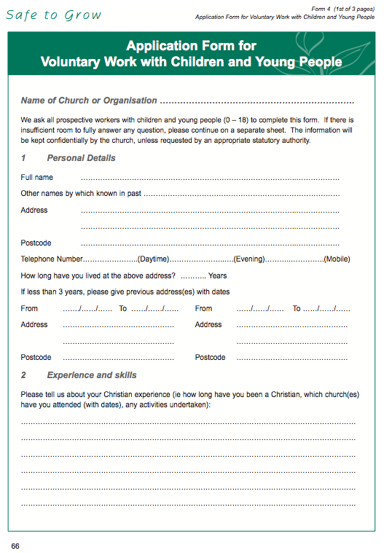
Appendix 1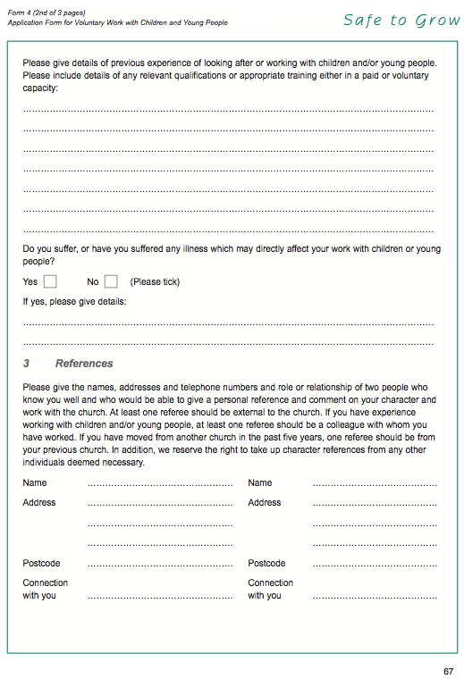
Appendix 1
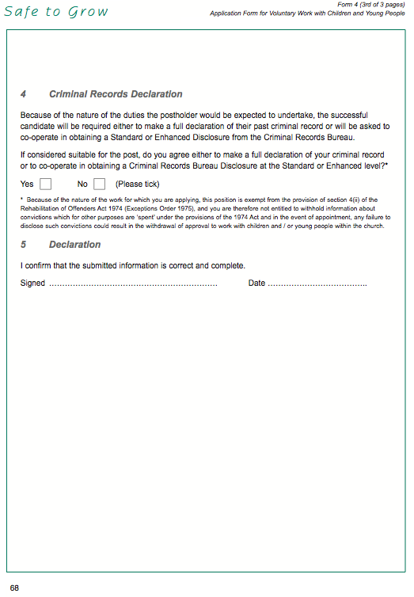
Appendix 2 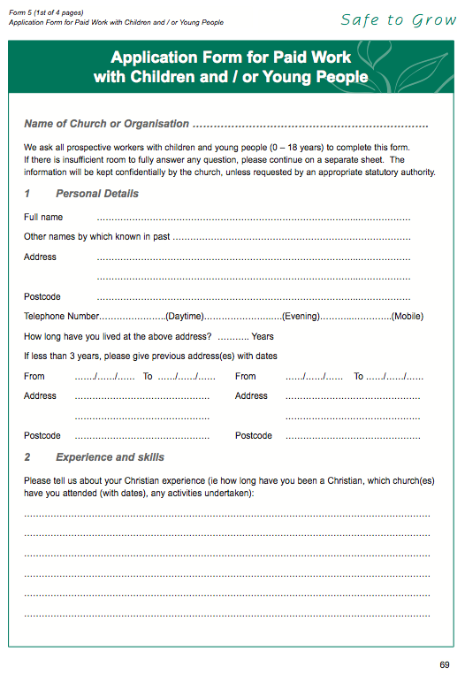
Appendix 2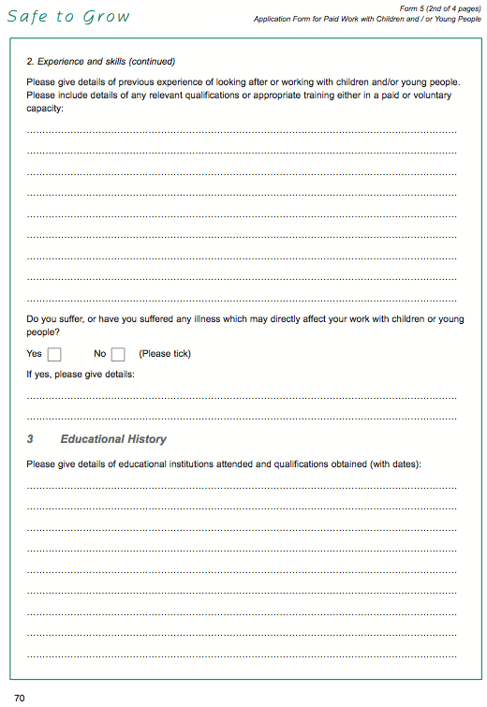
Appendix 2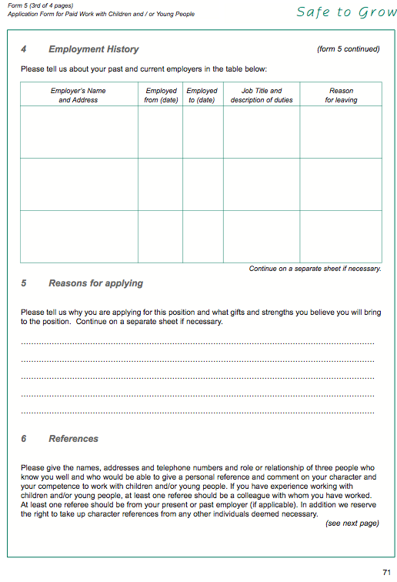
Appendix 2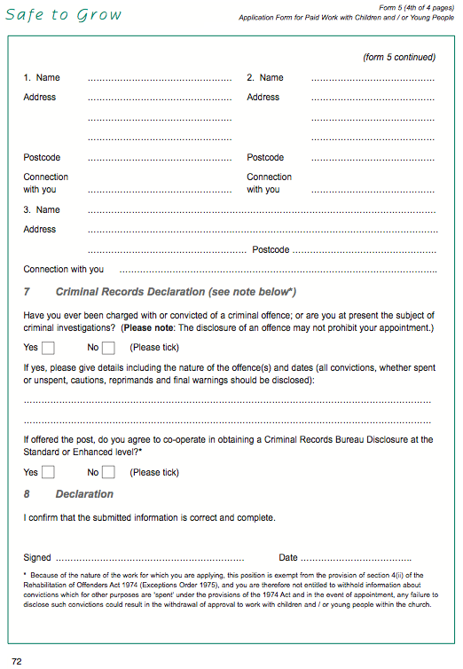
Appendix 3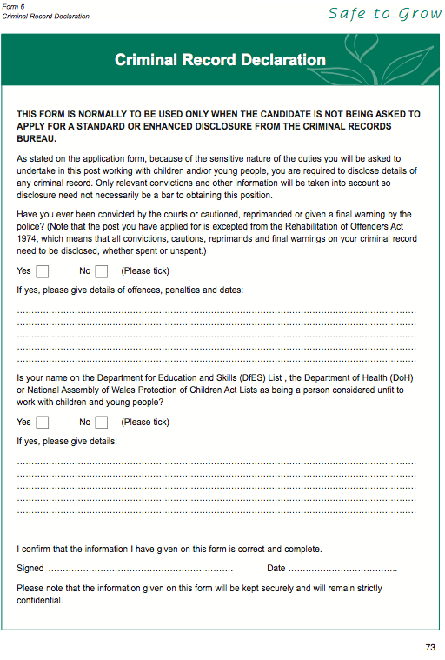
Appendix 4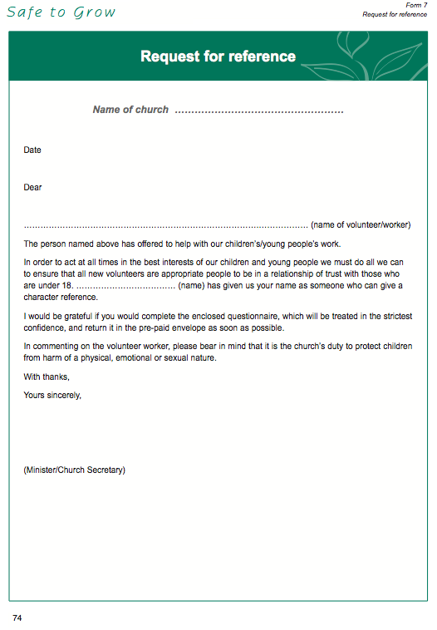
Appendix 5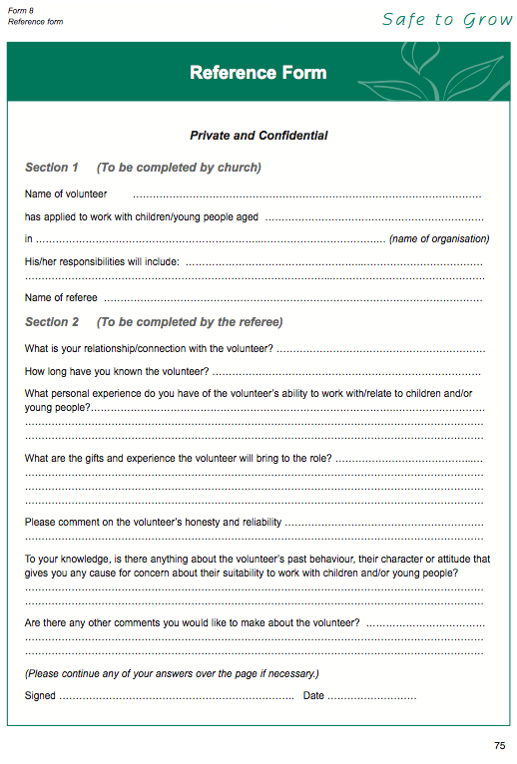
Appendix 6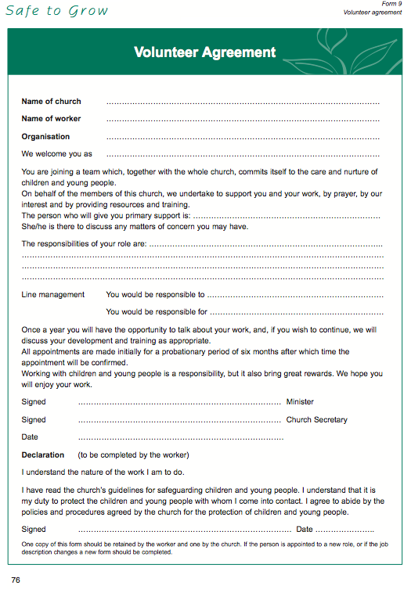
Appendix 7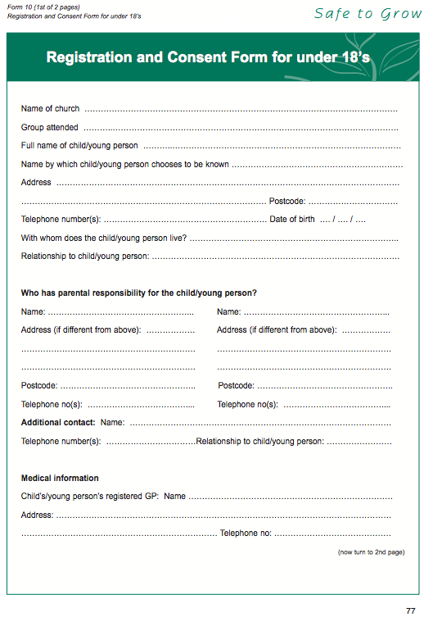
Appendix 7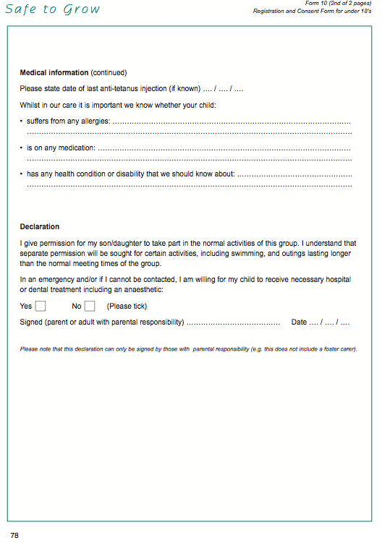
Appendix 8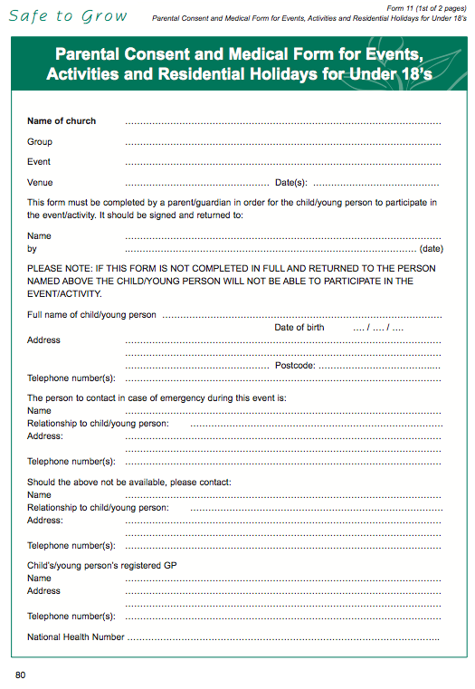
Appendix 8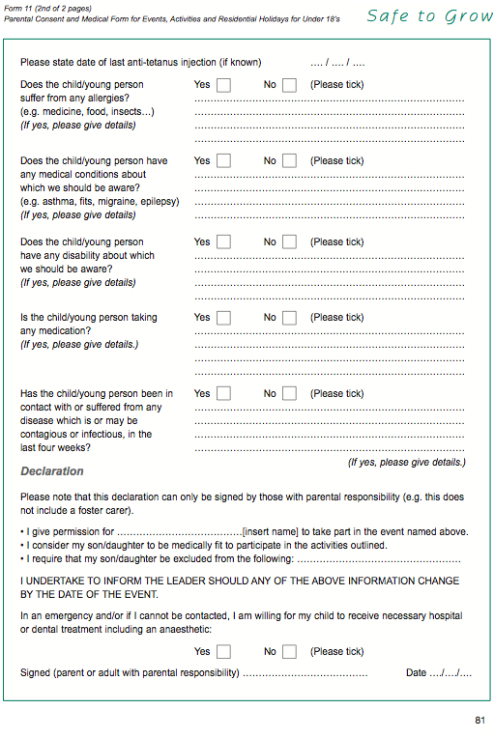
Appendix 9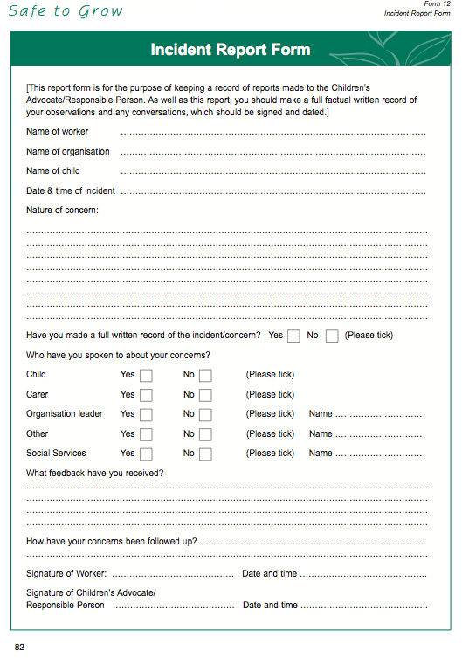
Appendix 10
Cairns Road Baptist Church
Children and Photography permission form
It is not illegal to take photographs of children (or vulnerable adults). However, it is important to protect children’s identities and prevent the misuse of photographic material. Newspaper editors work in accordance with the Press Complaints Commission’s Code of Practice and there is an emerging consensus of best practice for other organisations dealing with children. As a Church, we need to be responsible without being over-restrictive.
During our activities and groups at Cairns Road Baptist Church we often take photographs for publicity use later on.
We recognise that it is important to seek the permission from the parent or guardian anyone who is under 18 to use their image. We then ask all parents who have a child in our care or who attend our groups or activities to read, tick the appropriate boxes and sign in agreement bellow.
Please tick either yes or no according to your wishes:
I/we are happy for my child to have their photograph taken and archived safely
[ ] Yes [ ] No
I/we are happy for these photographs to be used for publicity but our child will not be identified by name
[ ] Yes [ ] No
Our permission will continue until our child reaches the age of 18 years, unless we otherwise give notice.
Name of child: _______________________________________
Signed: __________________________________ Parent/Carer
Date: ______________________________________________

Please return this form to either the group leader.

http://www.childcarseats.org.uk/law/index.htm#kids311
http://www.baptist.org.uk/resources/resource_downloads/190.pdf

